Working group on adjunctive protective equipment for high-risk procedures in SARS patients

Participants
Dr. Randy Wax, Critical Care/Simulation, MSH
Dr. Fabrice Brunet, Critical Care, St. Mikes
Dr. Yousouf Peerbaye, Emergency Medicine, SBK
Mark Castle, Toronto EMS/CBRN
Dr. Simon Abrahamson, Critical Care/Anaesthesia, St. Mikes
Dr. William Darrah, Critical Care/Anaesthesia, St. Mikes
Adam Dubrowski PhD, MSH Surgical Skills Centre/Centre for Research in Education
Sandra Devlin, Critical Care, St. Mikes
Karen Gaunt, Emergency Medicine, St. Mikes
Karen Green, Infection Control, MSH
Wayne Lee, Infection Control, MSH
Anne Augustin, Infection Control, SBK
Clare Barry, Infection Control, SBK
John Traill, Respiratory Therapy, MSH
Dr. Ron MacMillan, Provincial Operations Centre
James O’Donnell, Ministry of Health
Andrew Marshall, Ministry of Health
Teresa Seitz, Centers for Disease Control and Prevention
Joe Carpenter, Centers for Disease Control and Prevention
Lisa Satterthwaite, Surgical Skills Centre, MSH

April 25, 2003
Held at: Human Simulation Program/Surgical Skills Centre, Mount Sinai Hospital

NOTE:
The Working Group did not perform an exhaustive analysis of all available devices. There may be perfectly acceptable adjunct devices beyond those considered. The systems may be used differently than recommended by the manufacturer (e.g, N95 or N100 mask underneath systems).

Tasks

- To review options for adjunctive protection systems during high-risk situations when caring for SARS patients
- To evaluate candidate systems under simulated resuscitation situations
- To provide recommendations regarding use of adjunct systems and choice of adjunct systems

Methods

- Demonstration of 3 adjunct protective systems by industry representatives and Toronto EMS CBRN team members
- Discussions and questions regarding advantages/disadvantages of each system
- Simulated resuscitation scenarios of a SARS patient requiring intubation, operators only had one prior practice attempt at using gear, not a difficult airway situation.
- Stage 1: Donning standard and adjunct protective gear
- Stage 2: Entry to patient room and appropriate care leading to intubation of the patient
- Stage 3: Removal of adjunct protective gear, decontamination procedures

General recommendations

- N95 masks underneath adjunctive gear can provide a backup device for respiratory barrier in the event of an adjunct device failure.
- Prior to donning adjunct protective gear, N95 mask placement must be checked to ensure it will not slip after donning hoods or interfere with adjunct device function.
- Eye protection should include an elastic band or other device to ensure that the glasses/goggles will not slip position while under the hood.
- An electronic stethoscope with external speaker should be available for high-risk intubations to confirm endotracheal tube placement. One cannot use a standard stethoscope while wearing adjunct protective hoods. Other methods for confirming tube placement, such as CO2 detectors and/or esophageal detection devices should be used.
- At least one appropriately trained person in full protective gear (N95 mask, face shield, gown, gloves) must assist personnel exiting a room following a high-risk procedure. The exiting personnel should move as little as possible to avoid aerosolization of virus. All procedures for removing protective equipment should be done slowly and carefully. Removal of the equipment may be the period of highest risk for cross-contamination and requires special attention.
- Easily visible step-by-step checklists for entry and exit may help achieve total compliance with procedures.
- Clear procedures must be created for any adjunct device to ensure consistent and safe use.
- Thorough training of personnel on the use of adjunct devices and protocols is mandatory. The use of simulators or intubating mannequins combined with hands-on training with the equipment under observation by someone familiar with the device/protocols is helpful. Videotaped demonstrations would also likely benefit new users.

Systems evaluated in detail

- Stryker T4 Protection Device
- 3M AirMate PAPR Protection Device

Experience with Stryker T4 Protection Device

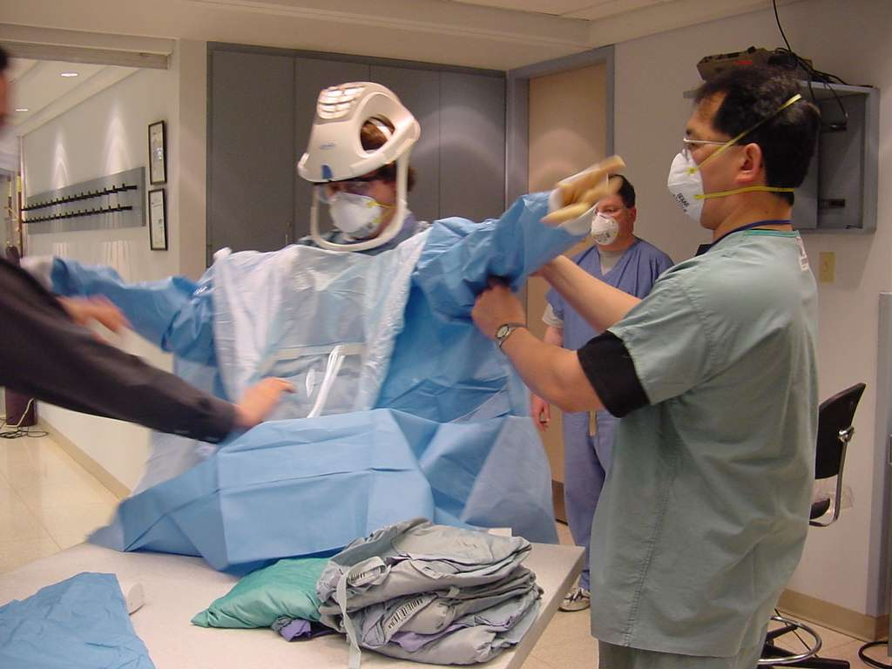
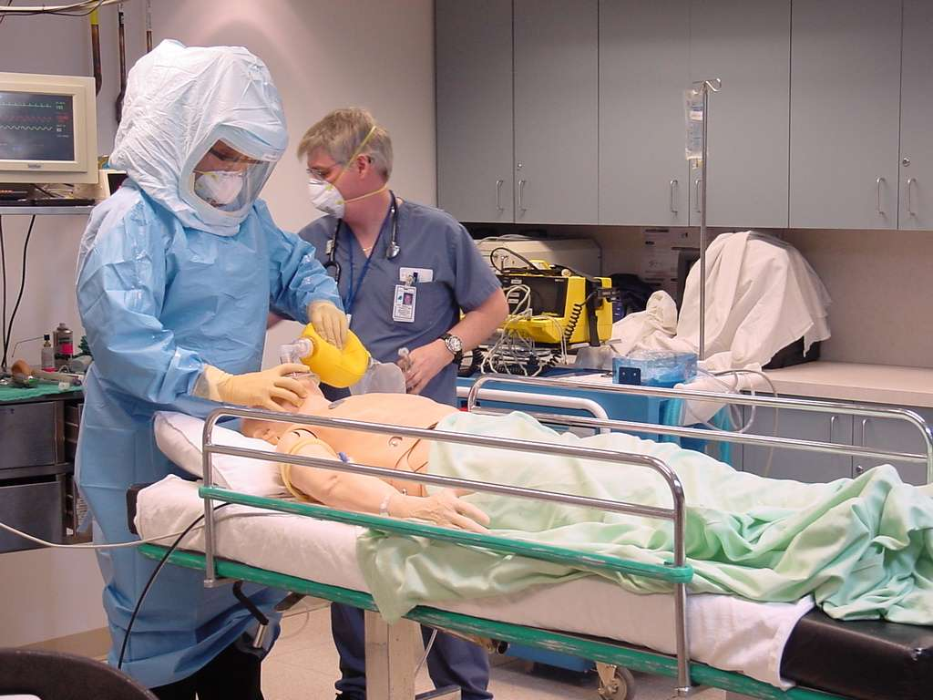
This device requires placement of a helmet followed by placing a hood over the helmet containing a large visor. Although a shorter hood is available, we recommend the use of the long “toga” version of the hood to provide better barrier precautions and to prevent updraft of external air reaching the face. Alternatively, wearing a short hood underneath followed by placing a full “toga” hood over top provided excellent comfort, excellent visibility, additional barrier, and easy removal. This approach avoids having to wear a double gown underneath or a full body disposable suit. The helmet is connected to a rechargeable power pack which can be clipped to the pants or a belt. The hood itself is the filter, which is disposed after the procedure.

In our simulation, the Stryker T4 device was donned along with usual gowns/gloves/N95 mask/eye shield in 1 minute 32 seconds. Infection control confirmed that the device was in place correctly. After entering the patient room, it took 2 minutes 30 seconds for the patient to be sedated, paralyzed and successfully intubated.

Advantages:
- Quiet fan motor allowed easier communication with other personnel, can hear changes in oxygen saturation tone
- Stryker T4 more comfortable to wear than PAPR hood, remained cooler
- Excellent field of vision
- Toga hood was flexible, would allow comfortable performance of other procedures (e.g., placement of central line)
- Less chance of contamination of adjunct device than PAPR hood; entire hood is disposable, helmet and battery pack are not exposed to droplets and can be easily wiped and decontaminated

Disadvantages:
- Because this does not create a positive pressure environment, the air supply for the operator is not completely isolated for airborne transmission. This device should not be used for SARS patients if further analysis of spread mechanisms include airborne spread.
- This device is not NIOSH approved. The manufacturer provides data to compare with NIOSH approved respirators. Review of manufacturer’s specification data should be conducted by experts in occupational health and infectious disease to ensure that it has been appropriately tested.

Experience with 3M PAPR AirMate Hood

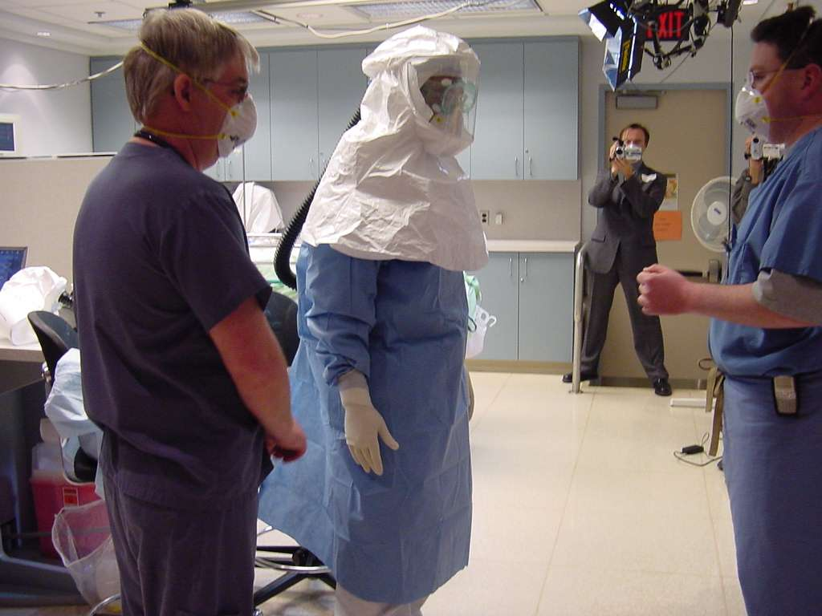
This device requires placing a power pack/fan/HEPA filter device around the waist with a belt, then connecting a corrugated tube to a hood with a visor, which is placed over the head. A short version of the hood was felt to be insufficient barrier protection for operators due to multiple holes just below the mouth. With high minute ventilation, it was felt that the air supply from the device may not maintain the positive pressure environment and allow contaminated air to enter the hood near the mouth. Thus, it was recommended that only the long hoods should be used. The hood is disposable, however the corrugated tube and power pack/fan/HEPA filter unit must be cleaned externally.

In our simulation, the 3M AirMate Hood (long version) was donned over top a disposable full body suit and gown, along with gloves, N95 mask, goggles. It took 2 minutes 45 seconds to don this device. Infection control confirmed that the device was placed correctly. After entering the room, it took 1 minute 54 seconds to be sedated, paralyzed and successfully intubated.

Advantages:
- Positive pressure environment may be safer if airborne spread suspected

Disadvantages:
- Loud fan interfered with communication between personnel, although the intubator was able to hear oxygen saturation tones from pulse oximeter
- Operator became hot, uncomfortable and short of breath over the span of a few minutes
- Movement was limited if attempts at central line placement etc. attempted
- Removal of device was more complicated than T4 Stryker, creating higher risk for cross-contamination
- Concern was raised about difficulty in decontaminating the power pack and corrugated hose; observers from CDC suggested that hoses could be one-time use only because of difficulties in decontamination
- Concern was raised that the filter would be contaminated by virus and would not be decontaminated; removal of filter immediately after use is troublesome while still in patient room

Summary and Further Direction

This group felt that there were major advantages to the T4 Stryker Protection System over the 3M AirMate PAPR Hood System. The Stryker system was easier to use, more comfortable, quieter, and easier to remove. The Stryker system would be a much better choice for personnel who need to spend any prolonged period of time caring for a patient immediately after intubation or other high-risk procedures. Despite many negatives, the 3M PAPR Hood system did not impede intubation during this simulation, however difficult intubations or prolonged procedures may not be as well served by the 3M PAPR.

This document will be forwarded to the GTA Critical Care Advisory Group to POC for further comment and recommendations. The next steps for this group will be to devise clear procedures for using either or both devices, and create effective training material. Further, a plan for purchase, distribution and implementation of these devices on a large scale will need to be created by the POC or other responsible group. The creation of a large number of trainers who undergo a detailed education process would help; personnel from Toronto CBRN team may be available to help with this training task. Current availability of simulators and airway mannequins should be assessed for institutions needing these devices, and plans for sharing or purchase of such training devices should be generated.

Please contact Dr. Randy Wax at randy.wax@utoronto.ca or via pager at 416-390-8760 for any questions or comments about this document.

